Volunteers needed for research study

We need volunters for a research study : The effect of electronic stimulation and foot position on post-stroke hemiparetic sit-to-stand.

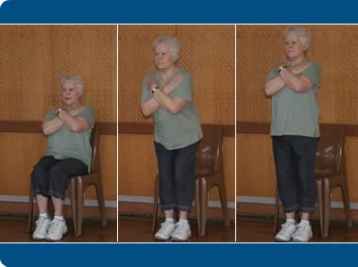

Description of study: We are investigating the effect of electrical stimulation , applied to the quadricep, soleus and gluteus maximus muscles, on stroke survivors during the sit-to-stand task.

To participate :

* Must have had a single stroke & suffer from hemiparesis
* Be at least 6 months since last stroke
* Be able to independently stand from a seat, without arms
* Be able to understand and follow verbal commands

Contact :

* Primary investigator = Key Nahan
* keynahan6@gmail.com

Key Nahan, FES stroke STS study at UT Austin

keynahan6@gmail.com

Key Nahan, FES stroke STS study at UT Austin

keynahan6@gmail.com

Key Nahan, FES stroke STS study at UT Austin

keynahan6@gmail.com

Key Nahan, FES stroke STS study at UT Austin

keynahan6@gmail.com

Key Nahan, FES stroke STS study at UT Austin

keynahan6@gmail.com

Key Nahan, FES stroke STS study at UT Austin

keynahan6@gmail.com

Key Nahan, FES stroke STS study at UT Austin

keynahan6@gmail.com

Key Nahan, FES stroke STS study at UT Austin

keynahan6@gmail.com